Challenge Lab Assignment (30 points)
In this assignment, you are required to complete following 5 challenge labs from the AWS Academy Cloud Architecting course. After you complete each lab, you need to capture a screenshot of the submission report and attach it under each section below.
This Youtube video explains how to capture the submission report. Please watch it before you start the assignment. This github repo includes links to the lab walkthrough videos that you might find helpful.
Module 4 Challenge Lab: Creating a Static Website for the Café
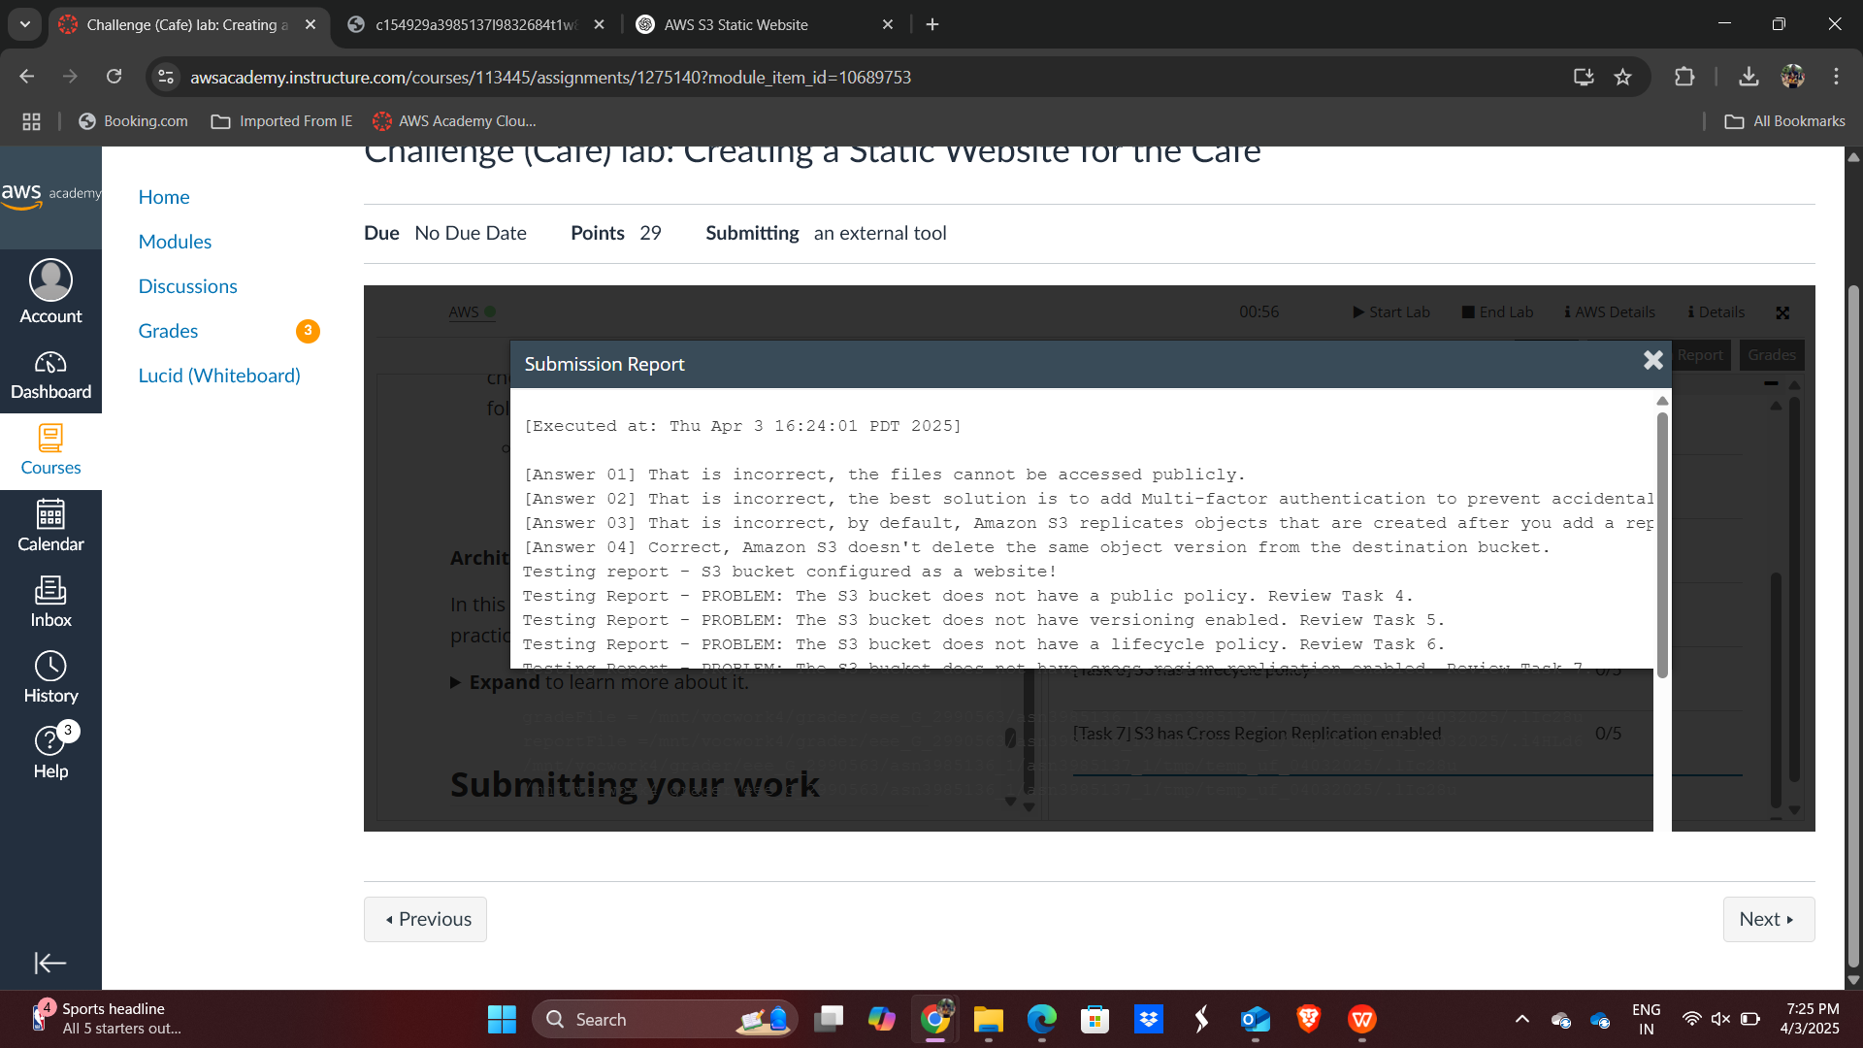

Module 5 Challenge Lab: Creating a Dynamic Website for the Café
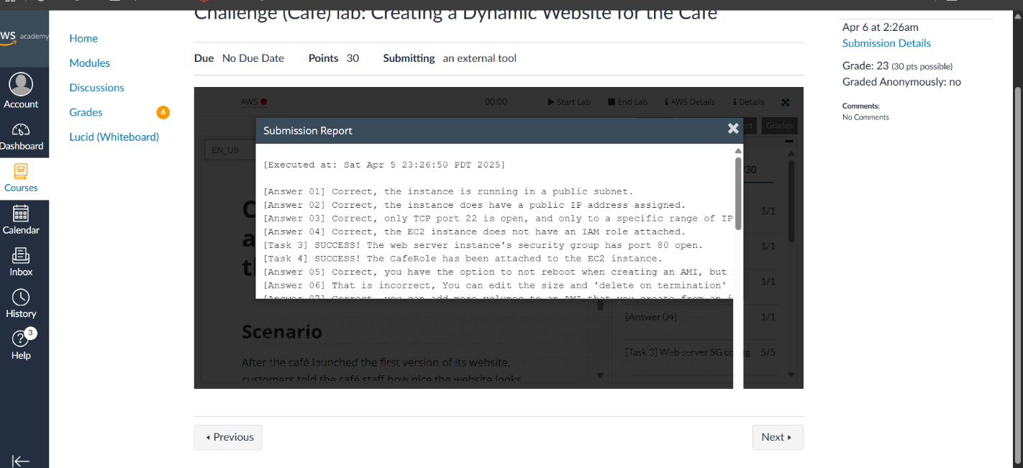

Module 7 - Challenge Lab: Creating a VPC Networking Environment for the Café
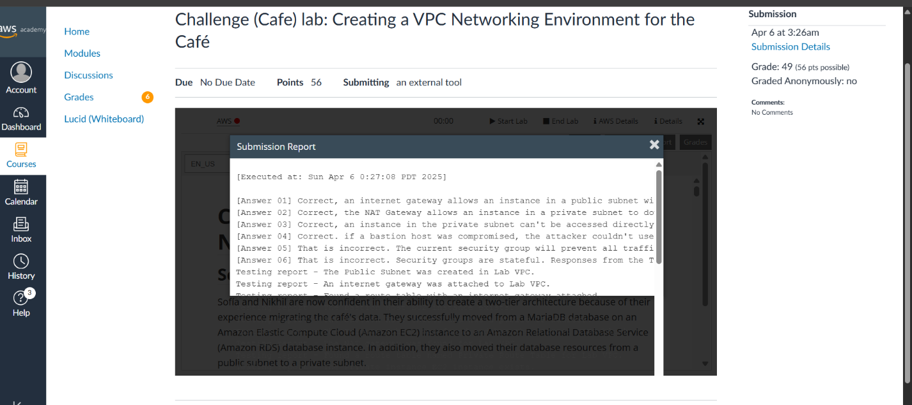

Module 10 - Challenge Lab: Creating a Scalable and Highly Available Environment for the Café
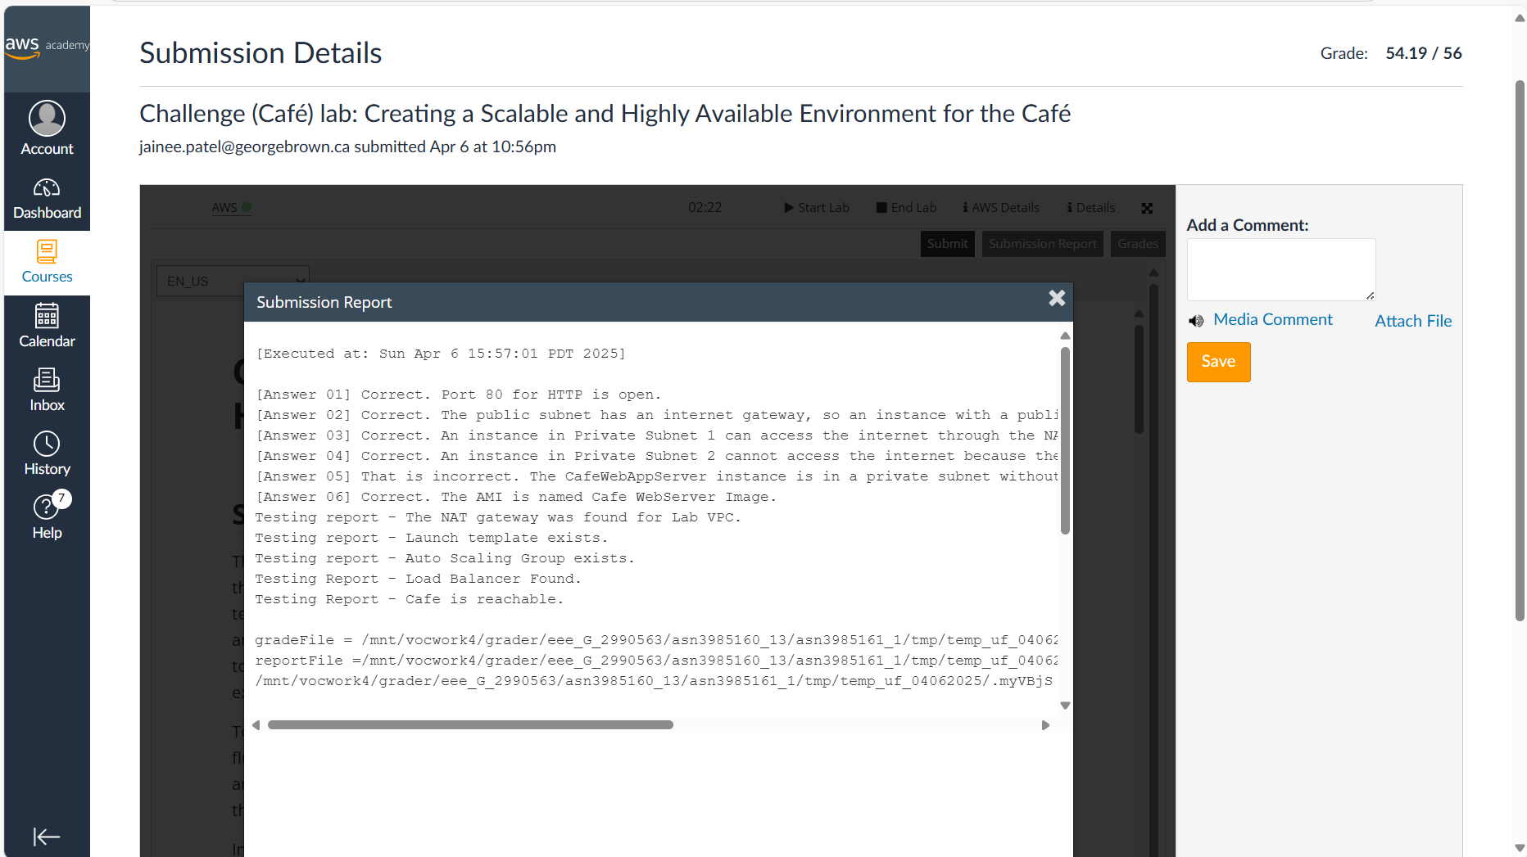

Module 14 – Challenge Lab: Implementing a Serverless Architecture for the Café
